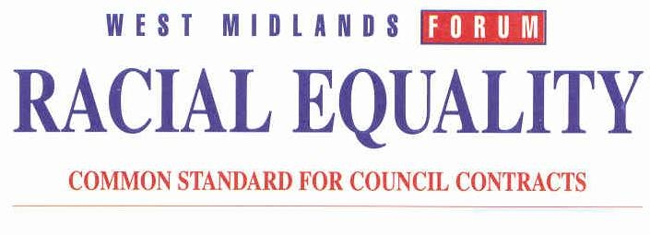
Solar Windows Ltd Ref: 242

28 July 2026

FAO – Robert Jenkins

WEST MIDLANDS FORUM COMMON STANDARD FOR EQUALITIES IN PUBLIC PROCUREMENT – LEVEL OF ACCREDITATION

I am pleased to inform you that your company has achieved level 2 of the Common Standard. The accreditation will run for a period of three years from the first date of entry onto an approved list operated by any of the six member authorities of the West Midlands Forum.

This letter may be used as evidence that you meet the Racial Equality Common Standard criteria when you apply to be included on approved lists operated by any of the six member authorities.

You should note that the accreditation is in respect of Equal Opportunities only and that you will still be required to satisfy any other criteria required by each member council (prior to being admitted to their approved lists).

The level of accreditation is relevant to the size of your company therefore you must notify me should there be a change in the size of your workforce, which would require you to achieve the next level.

Should you require any further information please do not hesitate to contact me on 01527 64252 ext 3160

Yours Faithfully

Ron Colebrook
Contracts Officer
Redditch Borough Council
